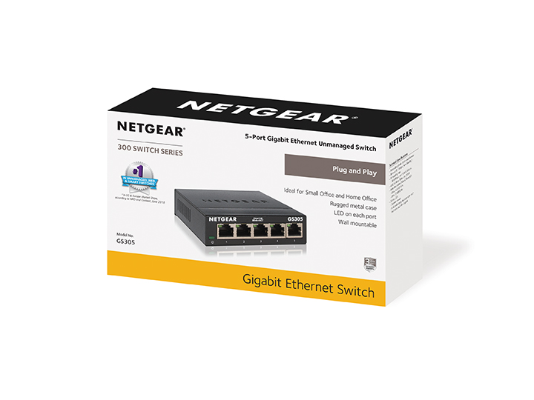Category

Unmanaged Switches

Product Name
5-port Gigabit Ethernet Unmanaged Switch
(GS305)

Model Number
GS305

Ecom Product Name
NETEGEAR® 5-port Gigabit Ethernet Unmanaged Switch
(GS305)

Package Contents

- 5-Port Gigabit Ethernet Unmanaged Switch (GS305v2)
- Power adapter (5V DC, 0.7A power output); plug is localized to country of sale
- Quick installation guide

Product Descriptions

15 words
The NETGEAR® 5-port Gigabit Unmanaged Switch is ideal for small office and home office use.

25 words
The NETGEAR® 5-port Gigabit Unmanaged Switch is ideal for small office and home office use. It is plug-and-play and features a rugged metal case.

50 words
The NETGEAR® 5-port Gigabit Unmanaged Switch provides an easy, reliable, and affordable way to expand your network connections in homes and small offices. It is plug-and-play and features a rugged metal case. Features also include Auto-MDI/MDIX, LED indicator on each port, energy-efficient technology, fanless design, auto-negotiation and non-blocking switching architecture.

Approved Category/Space Definitions
When referring to the “space" or category, the following is approved for all expected types of usage:

- 5-port switches
- Unmanaged switches
- SOHO switches
- Gigabit Ethernet switches
- Home office switches

Ordering Information

NETGEAR Part Number | UPC Number  (GTIN-12) | EAN Number  (GTIN-14) | Country
GS305-300JPS | 606449140118 | 10606449140115 | Japan
GS305-300PAS | 606449140088 | 10606449140085 | U.S. & Canada
GS305-300PES | 606449140095 | 10606449140092 | Europe General
GS305-300UKS | 606449140101 | 10606449140108 | UK

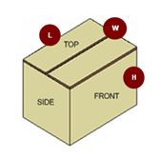

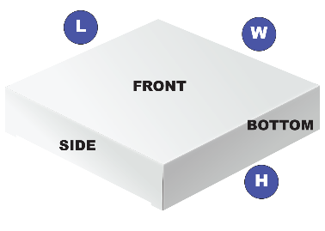

Warranty Details: |  |  |  | 3-year Limited Hardware Warranty*
 |  |  |  | 90 days of Technical Support
ProSUPPORT Installation Contracts |  |  |  | N/A
ProSUPPORT Support Contracts |  |  |  | PMB0S11-10000S OnCall 24x7 1-year Category S1
 |  |  |  | PMB0S31-10000S OnCall 24x7 3-year Category S1
 |  |  |  | PMB0S51-10000S OnCall 24x7 5-year Category S1
 |  |  |  | OnCall 24x7 extends the 90-day technical support for standard and advanced features to the length of the contract term.
ECCN |  |  |  | 5A991
HTS |  |  |  | 8517.62.0020
Country of Origin |  |  |  | China
*This product comes with a limited warranty that is valid only if purchased from a NETGEAR authorized reseller, and modifications to product may void the warranty; covers hardware, fans, and internal power supplies—not software or external power supplies; see http://www.netgear.com/about/warranty/ for details.

