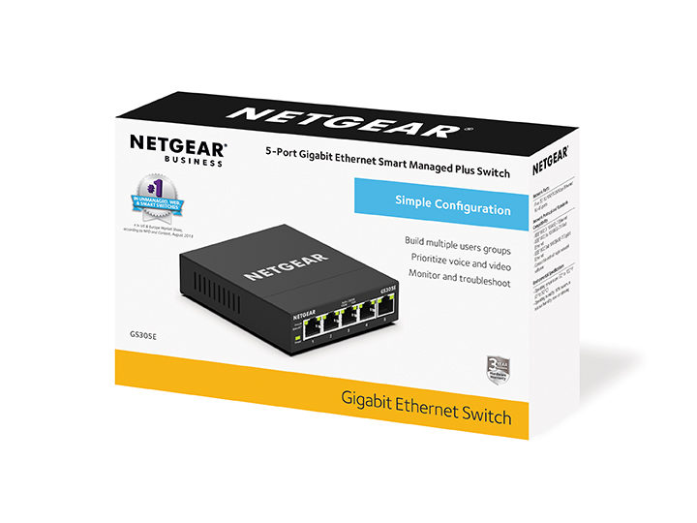Category

Smart Managed Plus Switches

Product Name
NETGEAR 5-port Gigabit Ethernet Smart Managed Plus Switch (GS305E)

Model Number
GS305E

Ecom Product Names

NETGEAR 5-port Gigabit Plus Switch (GS305E)

NETGEAR 5-port Gigabit Smart Managed Plus Switch (GS305E)

NETGEAR GS305E 5-port Gigabit Ethernet Smart Managed Plus Switch | Fanless | Easy management | Sturdy metal | Traffic priority and separation for security

Package Contents

- 5-port Gigabit Ethernet Smart Managed Plus Switch (GS305E)
- 12V, 1.0A power adapter, localized to country of sale

- Quick install guide
Not included: Category 5 or better Ethernet cable(s)

Approved Category/Space Definitions
When referring to the “space" or category, the following is approved for all expected types of usage:

- 5-port switches
- Managed plus switches
- Smart managed switches
- Gigabit Ethernet switches

Product Descriptions

15 words
The NETGEAR® 5-port Gigabit Smart Managed Plus Switch provides easy management and plug-and-play connectivity.

25 words
The NETGEAR® 5-port Ethernet Switch for Gigabit provides plug-and-play connectivity for your wired devices and easy web management for traffic priority (QoS) and traffic separation (VLAN).

50 words
Introducing the NETGEAR GS305E 5-port Gigabit Ethernet Smart Managed Plus Switch with traffic separation (VLAN), traffic priority (QoS), and multicast for streaming (IGMP) capabilities. Through an intuitive GUI it provides easy, reliable and affordable plug-and-play connectivity to quickly expand your business for workstations/servers, NAS storage, printers, and PCs with a fanless and sturdy metal design.

100 words
Introducing the NETGEAR GS305E 5-port Gigabit Ethernet Smart Managed Plus Switch with traffic separation (VLAN), traffic priority (QoS), Link Aggregation (LAG), cable health check and loop prevention. Through an intuitive GUI it provides easy, reliable and affordable plug-and-play connectivity to quickly expand your business for workstations/servers, NAS storage, printers, and PCs with a silent and sturdy metal design. GS305E also includes Energy Efficient Ethernet (IEEE 802.3az) for maximum power savings and comes with NETGEAR 3-year warranty and 90-day support.
Ordering Information

NETGEAR Part Number | UPC Number  (GTIN-12) | EAN Number  (GTIN-14) | Country
GS305E-100AUS | 606449140538 | 10606449140535 | Australia
GS305E-100JPS | 606449140583 | 10606449140580 | Japan
GS305E-100NAS | 606449140521 | 10606449140528 | North America
GS305E-100PES | 606449140569 | 10606449140566 | Europe & Asia
GS305E-100UKS | 606449140576 | 10606449140573 | UK

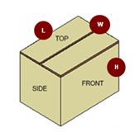

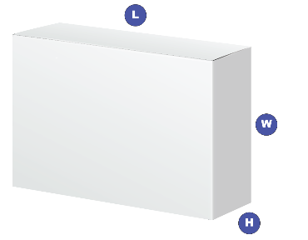

Warranty Details: |  |  |  | 3-year Limited Warranty* (1-year warranty in China/India)
 |  |  |  | 90 days free Technical Support with registration
ProSUPPORT Installation Contracts |  |  |  | N/A
ProSUPPORT Support Contracts |  |  |  | PMB0S11-10000S OnCall 24x7 1-year Category S1
 |  |  |  | PMB0S31-10000S OnCall 24x7 3-year Category S1
 |  |  |  | PMB0S51-10000S OnCall 24x7 5-year Category S1
 |  |  |  | OnCall 24x7 extends the 90-day technical support for standard and advanced features to the length of the contract term.
ECCN |  |  |  | 5A992
HTS |  |  |  | 8517.62.0020
Country of Origin |  |  |  | China
*This product comes with a limited warranty that is valid only if purchased from a NETGEAR authorized reseller, and modifications to product may void the warranty; covers hardware, fans,and internal power supplies—not software or external power supplies; see http://www.netgear.com/about/warranty for details.

